Blockchain Traceability for Sustainable Agriculture

Earlier we were heavily dependent on client and centralized server based communications where server contains all services with database and user can connect to server to access those services. Server managing administrator can aware of all database details and he can easily tamper database data and client has no way to know about data tamper. Traditional centralized server can get hack and in such situations server get crash and services to users will get disturbed.

To overcome from above centralized server disadvantages we are employing Blockchain technology to manage agriculture product details as Blockchain has inbuilt support for data encryption and data tamper proof which means once data store then it cannot be tamper in any manner. Using Blockchain tamper proof technique we can fight with counterfeit of agriculture products.

Blockchain store each record as transaction or block and associate each block with unique hash code and while storing new record Blockchain verify all previous blocks hash code and if hash code doesn’t match then Blockchain will revert to original state and avoid data tamper. Blockchain also support decentralized storage where each data will be record at multiple server or nodes and if one node down then user can access services from other working Blockchain nodes.

Above advantages of Blockchain leading us to manage agriculture details using Blockchain services where all products can be traced using hash code and can avoid counterfeit. Each product store in Blockchain associate with unique QR code and can get authenticated via that QR code.

To manage agriculture details in Blockchain we have designed following modules

1. Admin: admin can login to system using username and password as ‘admin’. After login admin will help farmers to add or update product details on behalf of farmers who don’t know about data feeding. Admin can view sales from consumers
2. Farmer: farmer can sign up and login to system and then can add or update product details and each stored product will have unique QR CODE for authentication. Farmer can view all sales details also
3. Consumer: consumer can sign up and login to system and then browse all products and then can purchase desired products.

All user data will be stored in Blockchain with the help of Smart Contract which can be designed using SOLIDITY programming. Smart contract contains function which can be called by user to store or retrieve data. Below is the smart contract code designed to manage agriculture products

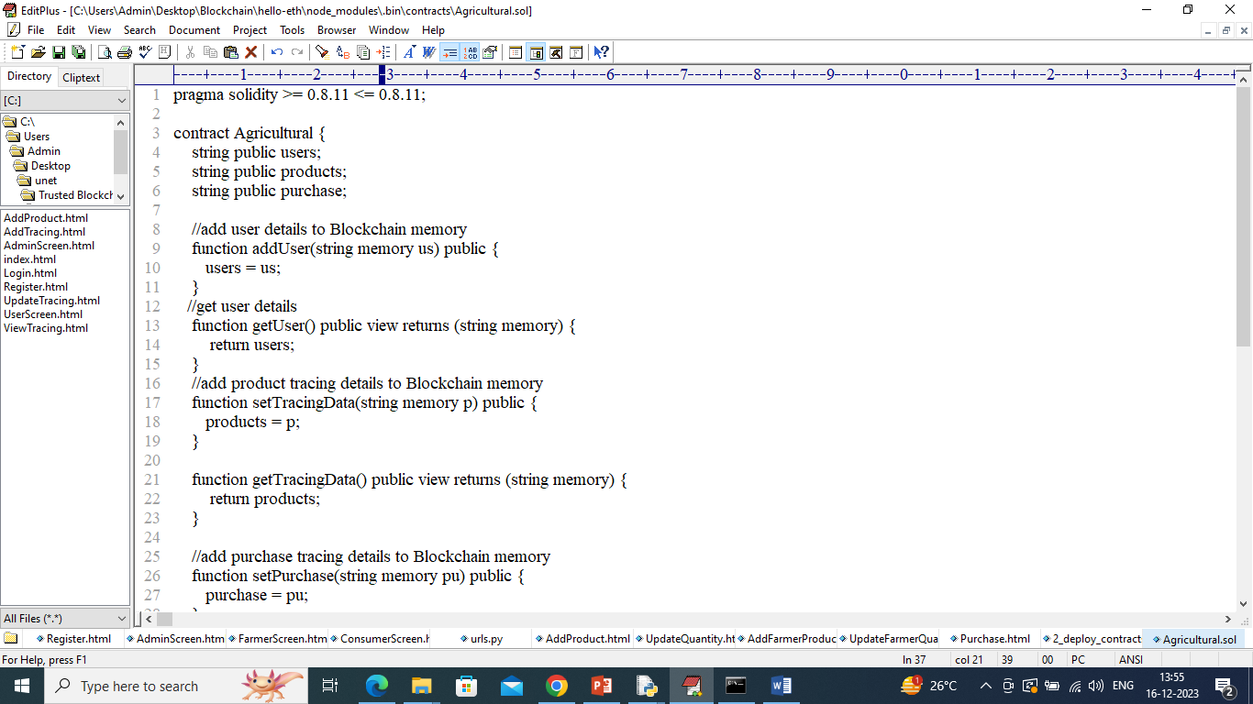

In above smart contract we can see functions defined for each operations and this function need to deployed in ETHEREUM Blockchain by following below steps

1. Go inside ‘hello-eth/node-modules/bin’ folder and then look and double click on ‘runBlockchain.bat’ file to get below screen
2. 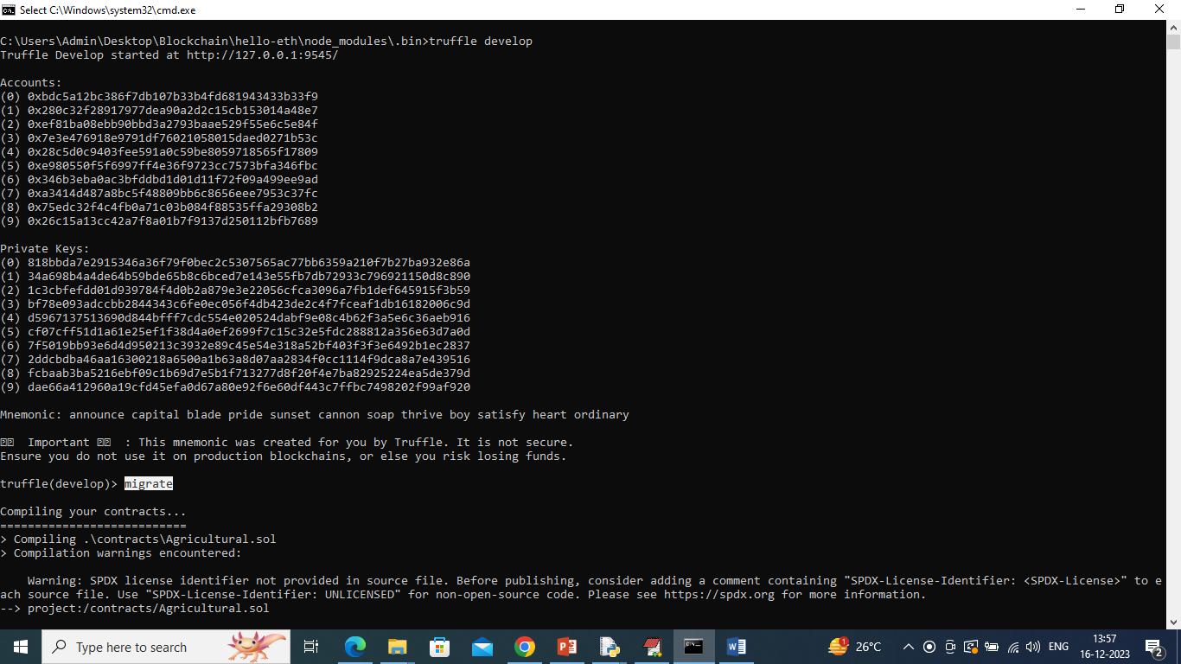
3. In above screen ETHEREUM started with default private keys and accounts and then type command as ‘migrate’ and press enter key to deployed contract and get below output
4. 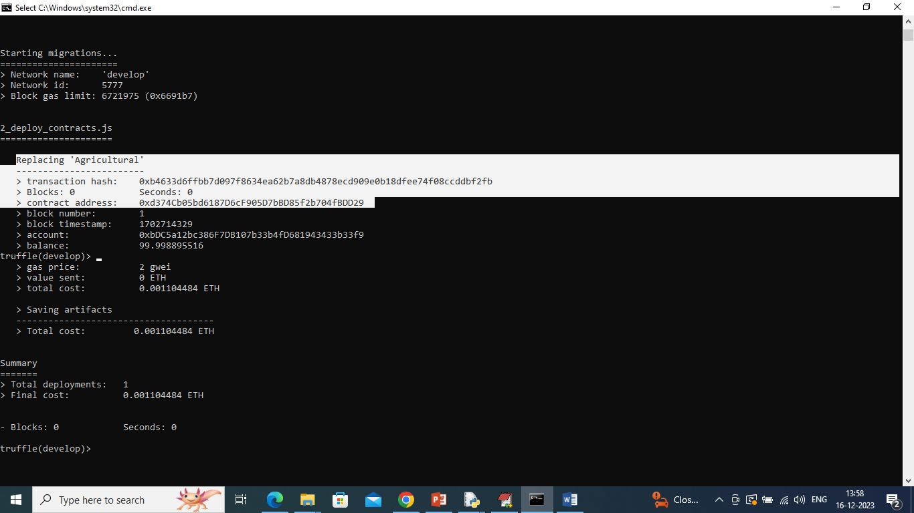
5. In above screen in white colour text can see ‘Agriculture’ contract deployed and we got contract address also and this address need to specify in PYTHON code to call contract to store and get data from Blockchain. In below screen showing python code calling Blockchain functions
6. 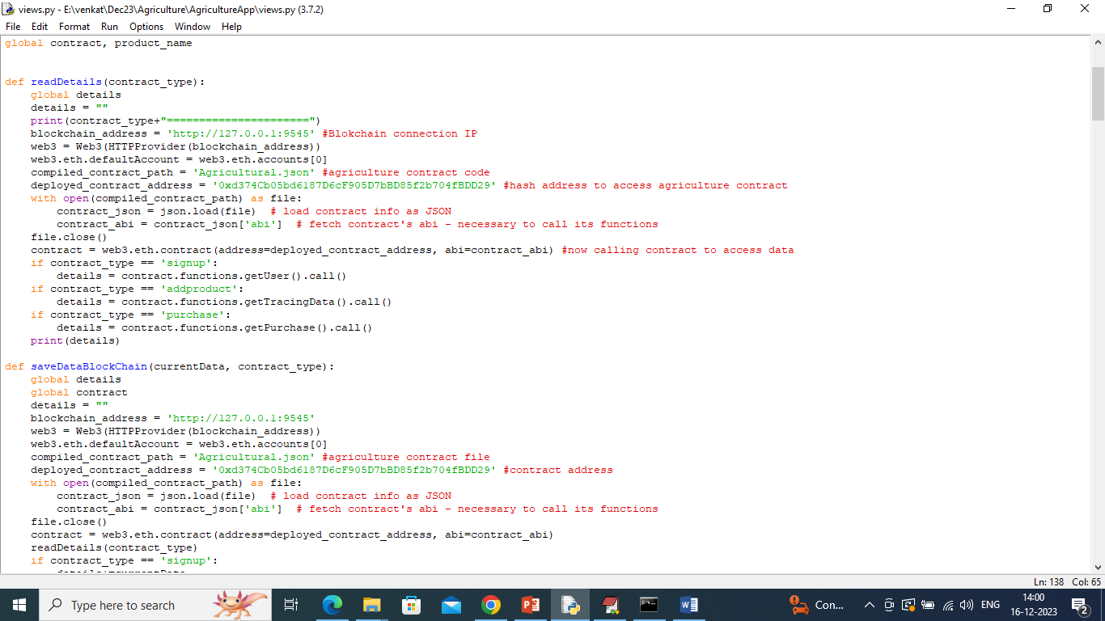
7. In above screen read red colour comments to know about contract calling from Blockchain. Now in previous Black screen can see Contract deployed in ETHEREUM and let it running.

SCREEN SHOTS

To run project double click on ‘run.bat’ file to start python server which will call ETHEREUM function to store and get data.

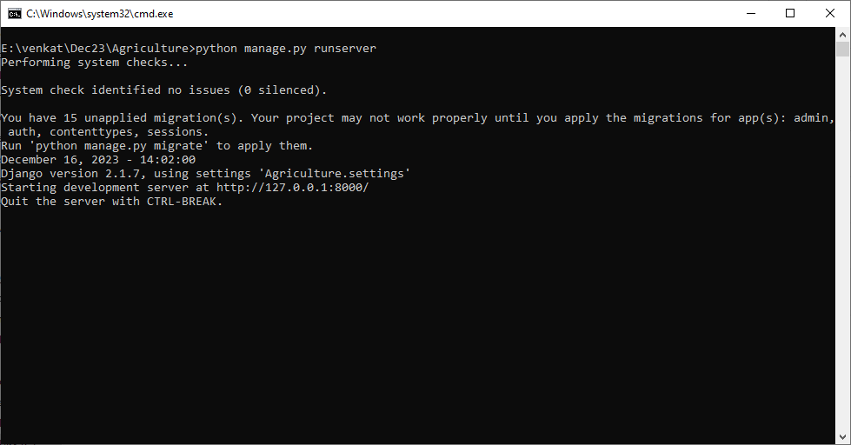

In above screen python server started and now open browser and enter URL as <http://127.0.0.1:8000/index.html> and press enter key to get below page

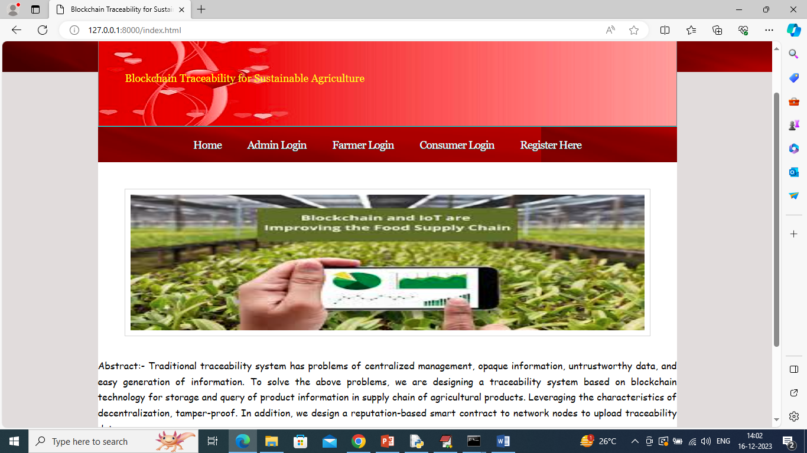

In above screen click on ‘Register Here’ link to allow farmers and consumers to sign up with the application

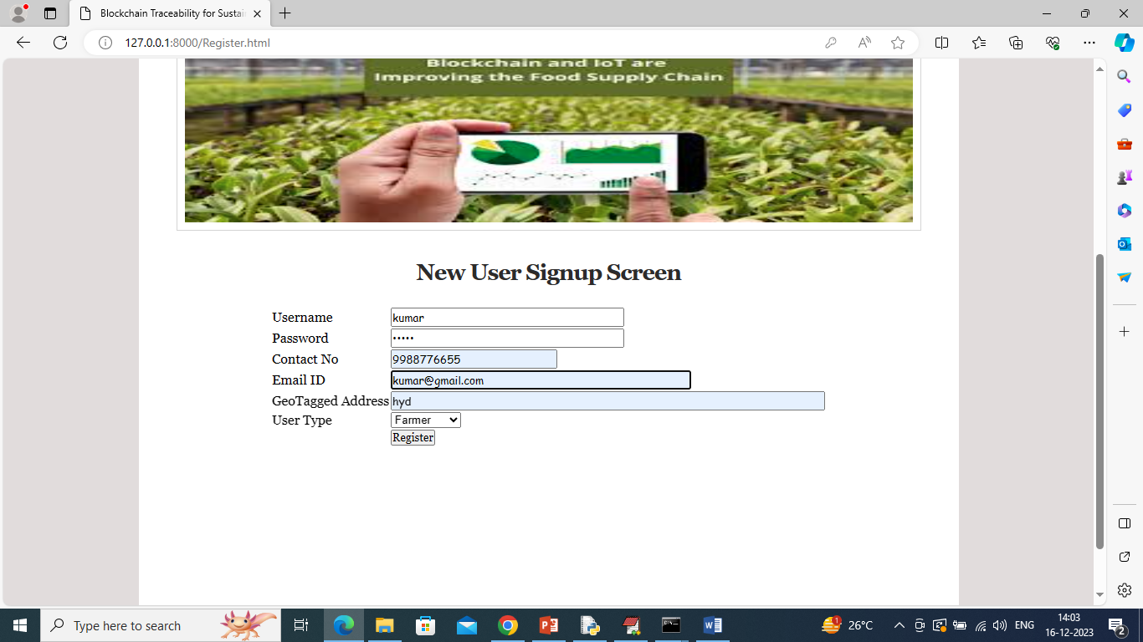

In above screen farmer is entering signup details and then press button to get below output

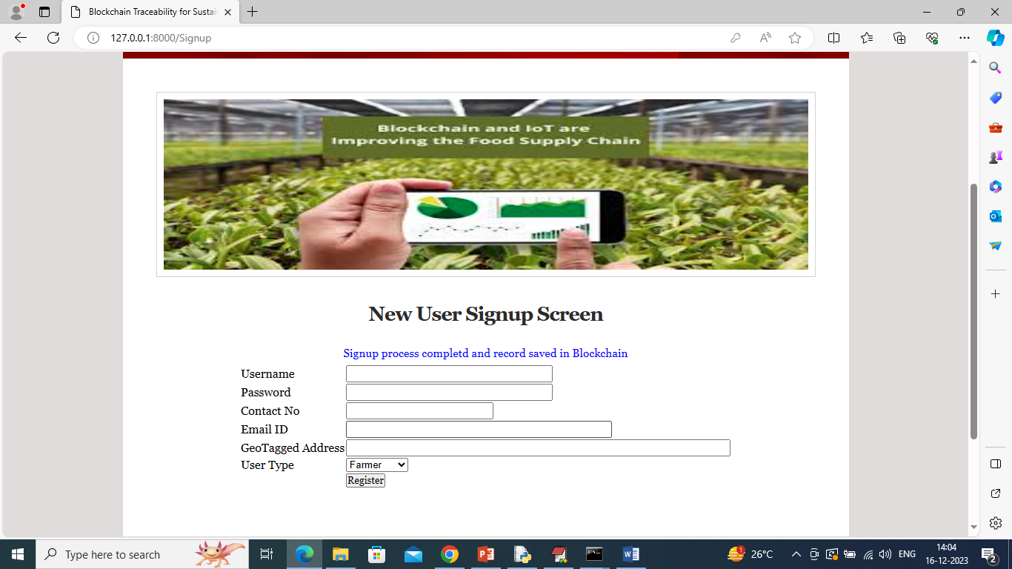

In above screen sign up completed and similarly you can add consumers and other farmers

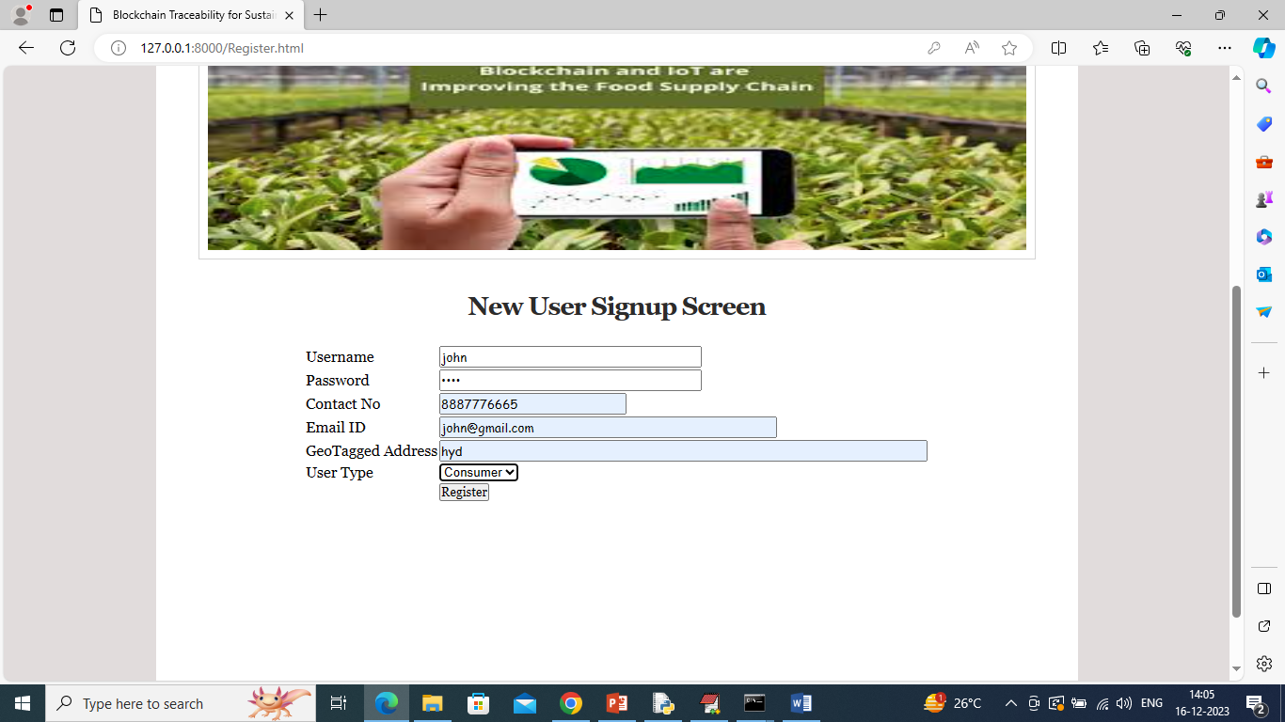

In above screen consumer is getting sign up and now click on ‘Admin Login’ link to get below page

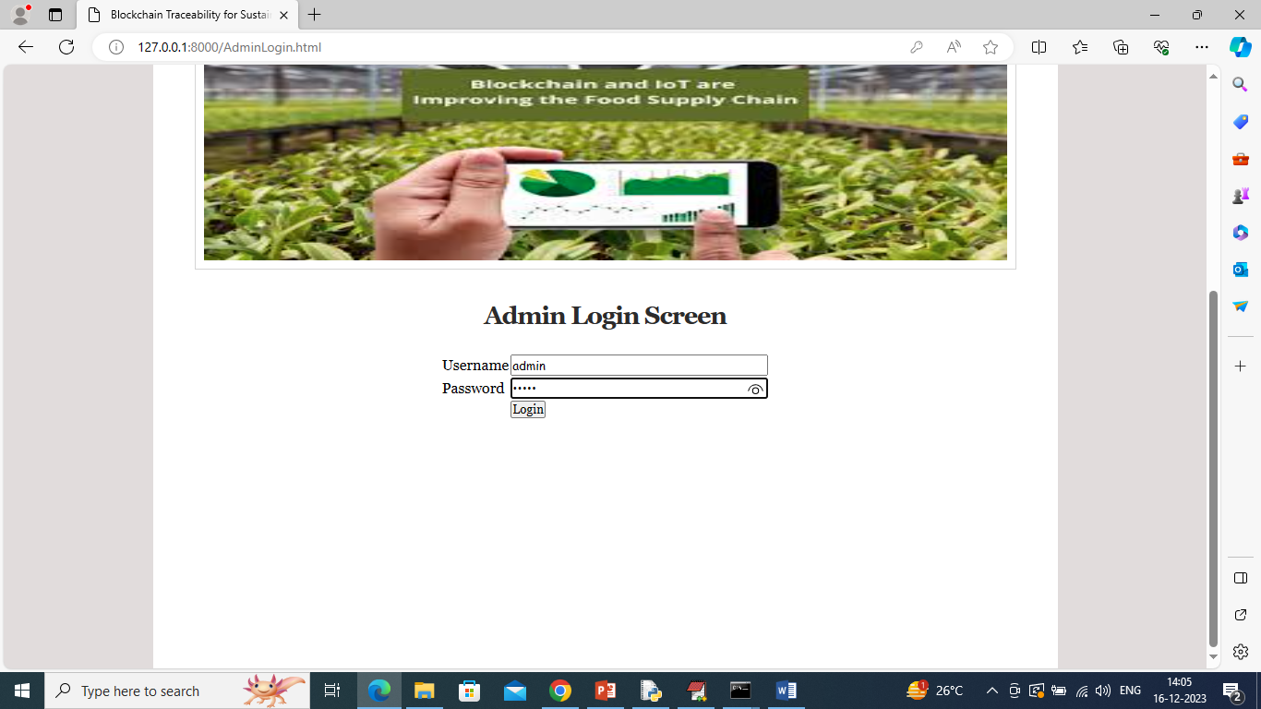

In above screen admin is login and after login will get below page

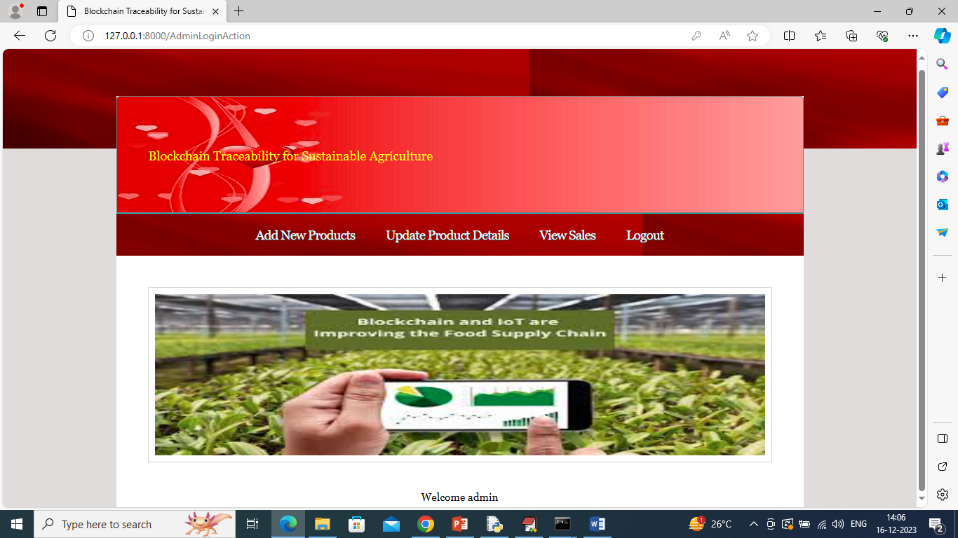

In above screen admin will click on ‘Add New Products’ link to add product on behalf of Farmers

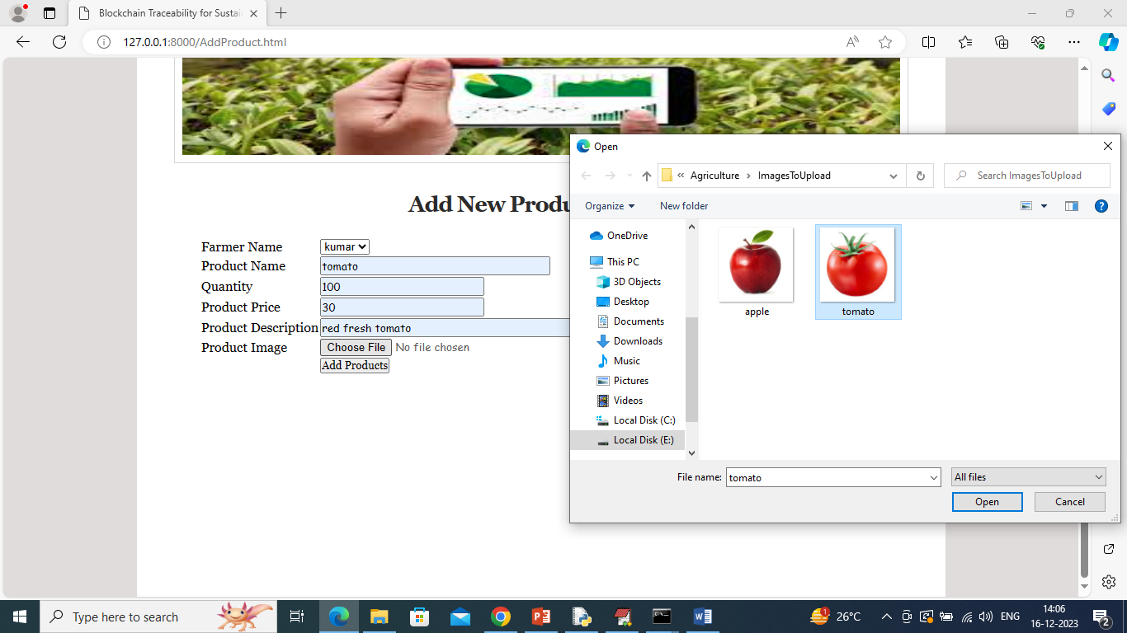

In above screen admin will select farmer name and add product details and then upload product image and then press ‘Add Product’ button to save details in Blockchain and get below page

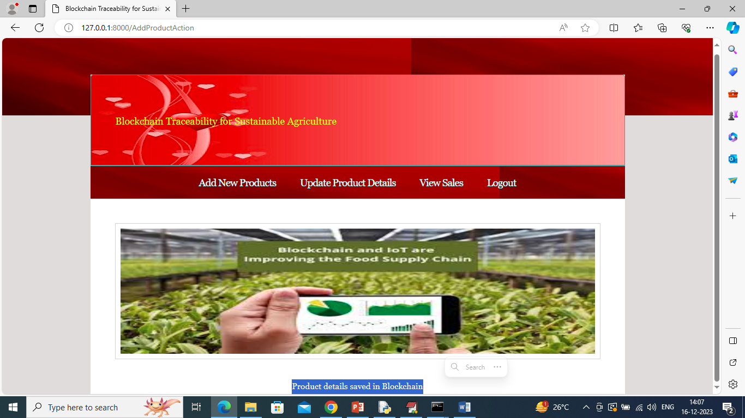

In above screen product details saved in Blockchain and now admin can click on ‘Update Products Details’ link to update quantity of product

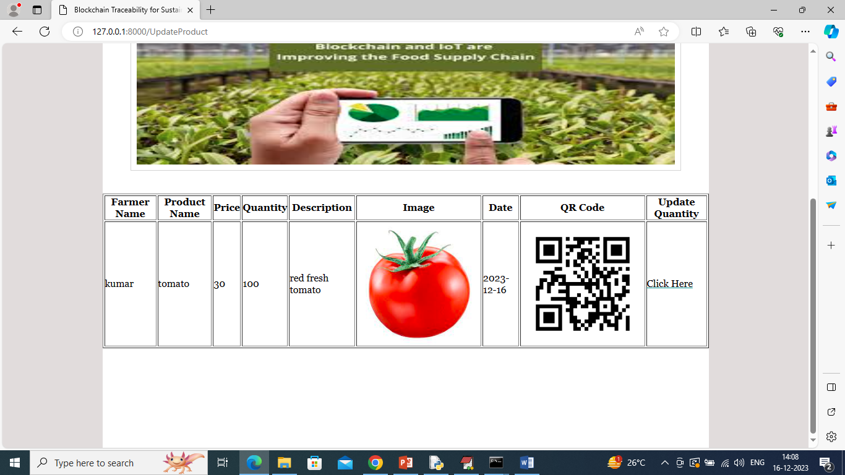

In above screen admin can view all farmers product details along with QR code and then can click on ‘Click Here’ link to update quantity of selected farmer products

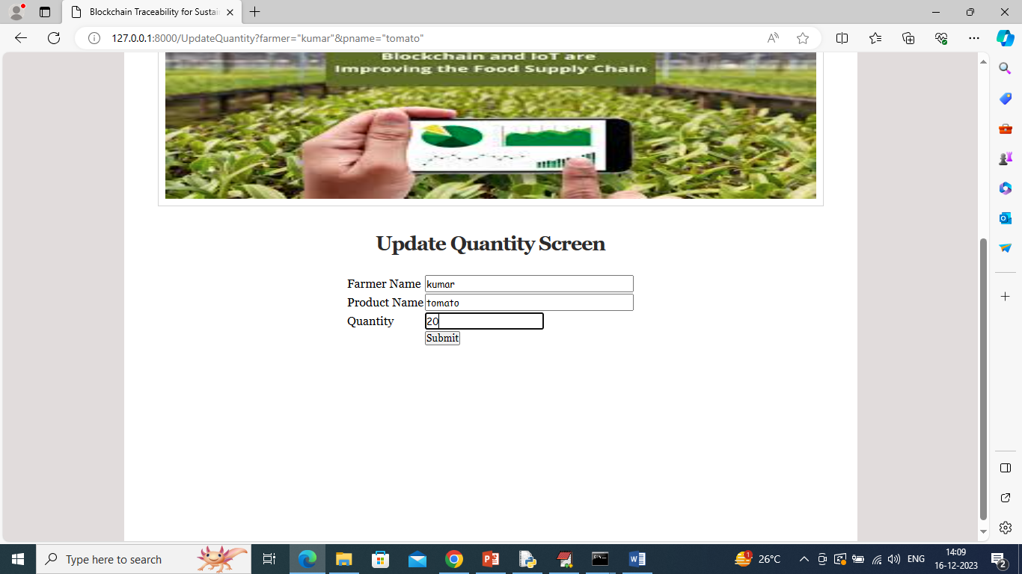

In above screen admin will enter quantity and then press button to update and get below page

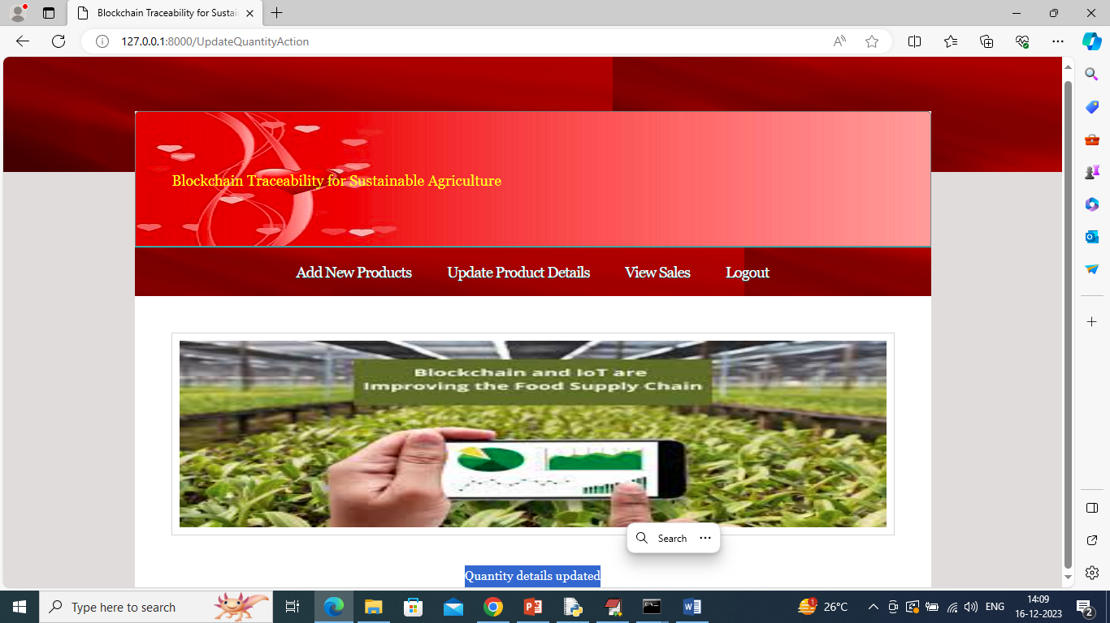

In above screen quantity updated and admin can click on ‘View Sales’ link to view sales from all consumers. Now logout and login as farmers who can enter their own product details without admin help

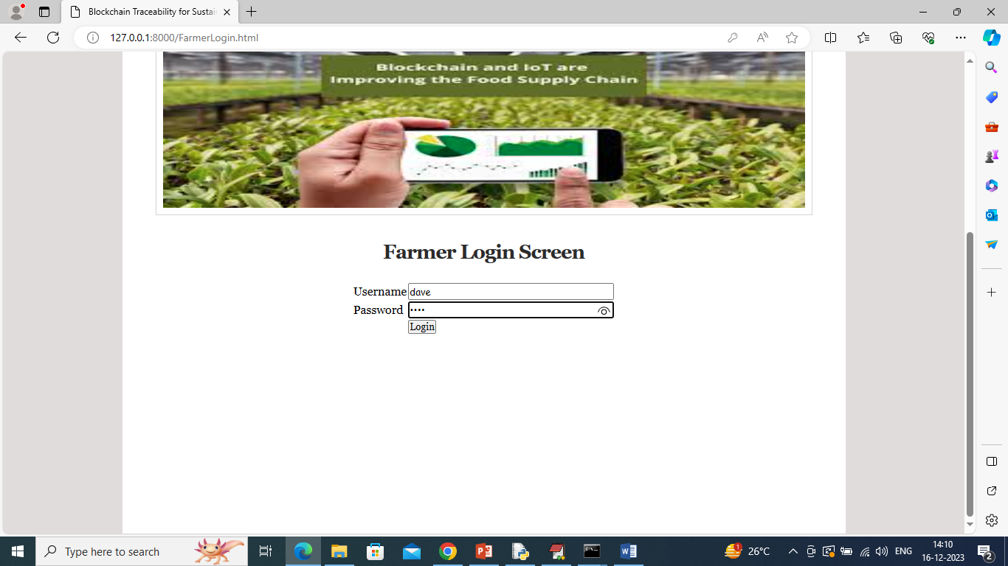

In above screen farmer is login and after login will get below page

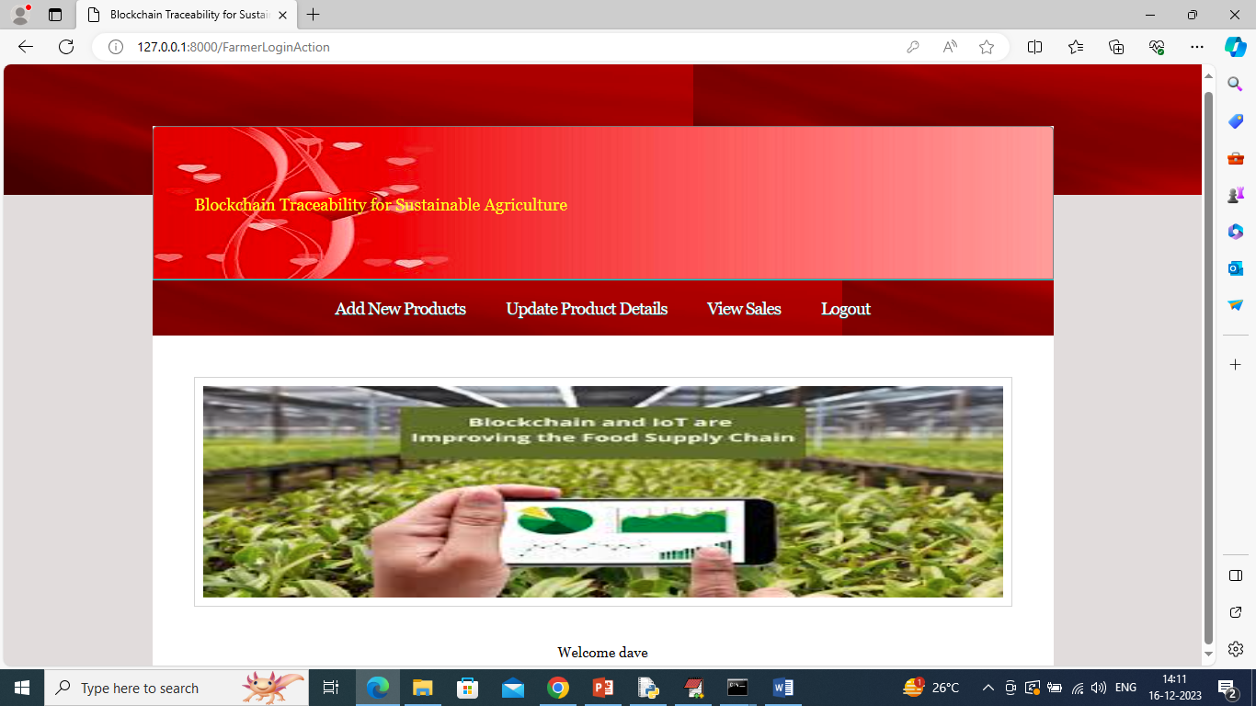

In above screen farmer can click on ‘Add New Products’ link to add his own products

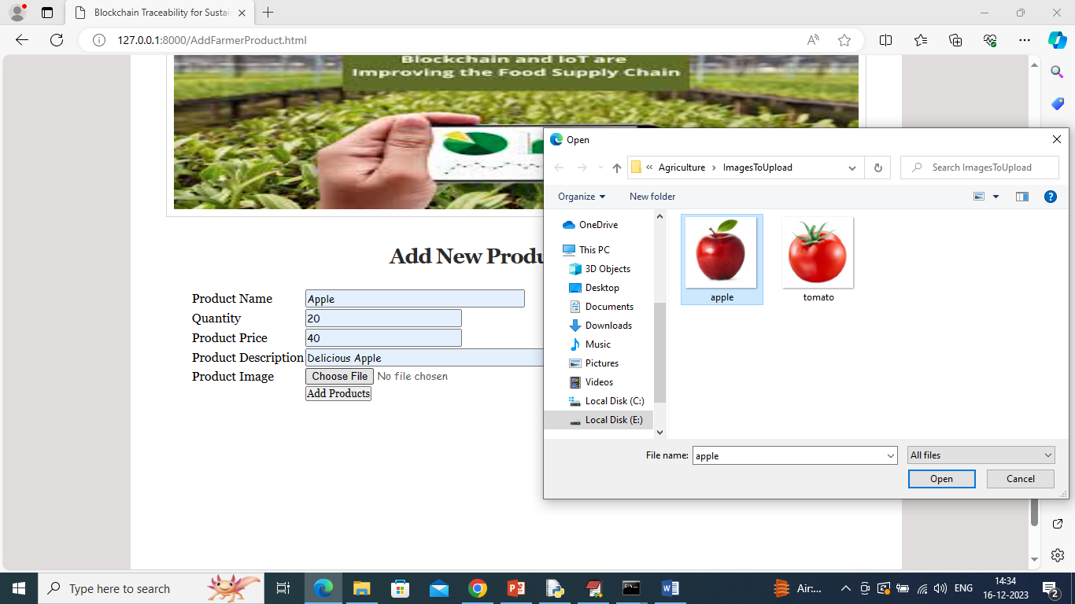

In above screen farmer can add his own product details and then press button to save details in Blockchain and get below output

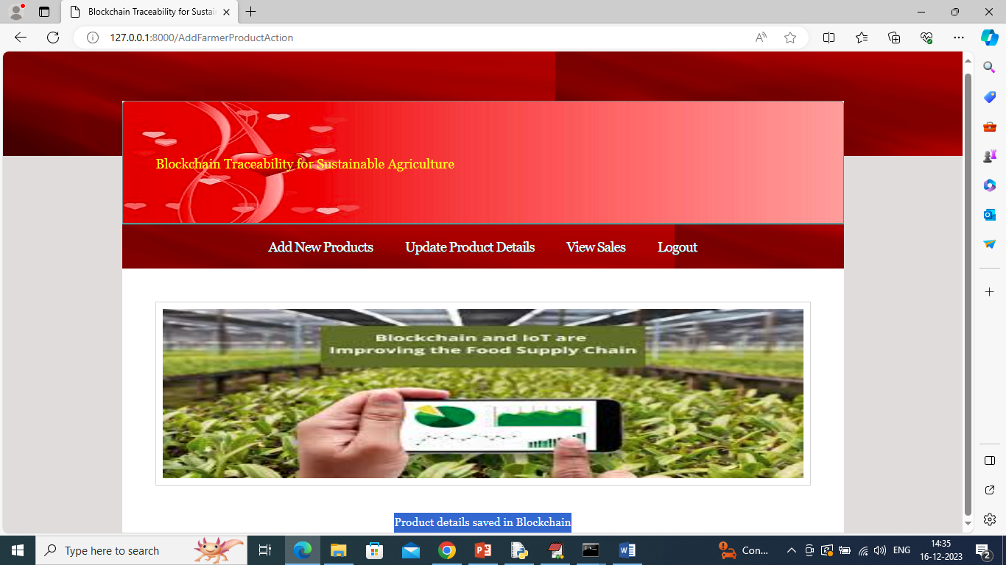

In above screen can see product details added and similarly you can update or view sales and now logout and login as consumers to purchase product

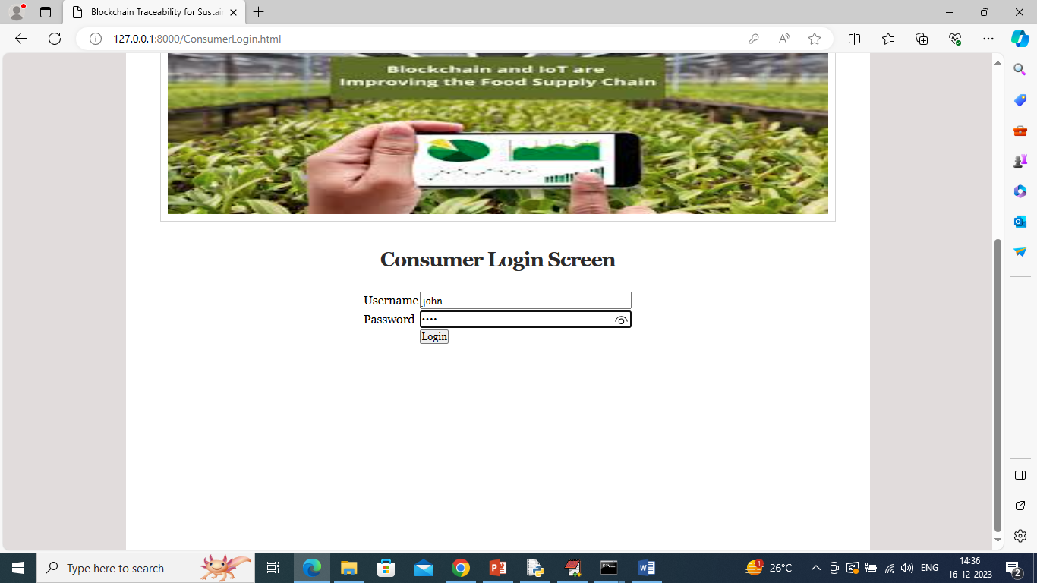

In above screen consumer is login and after login will get below page

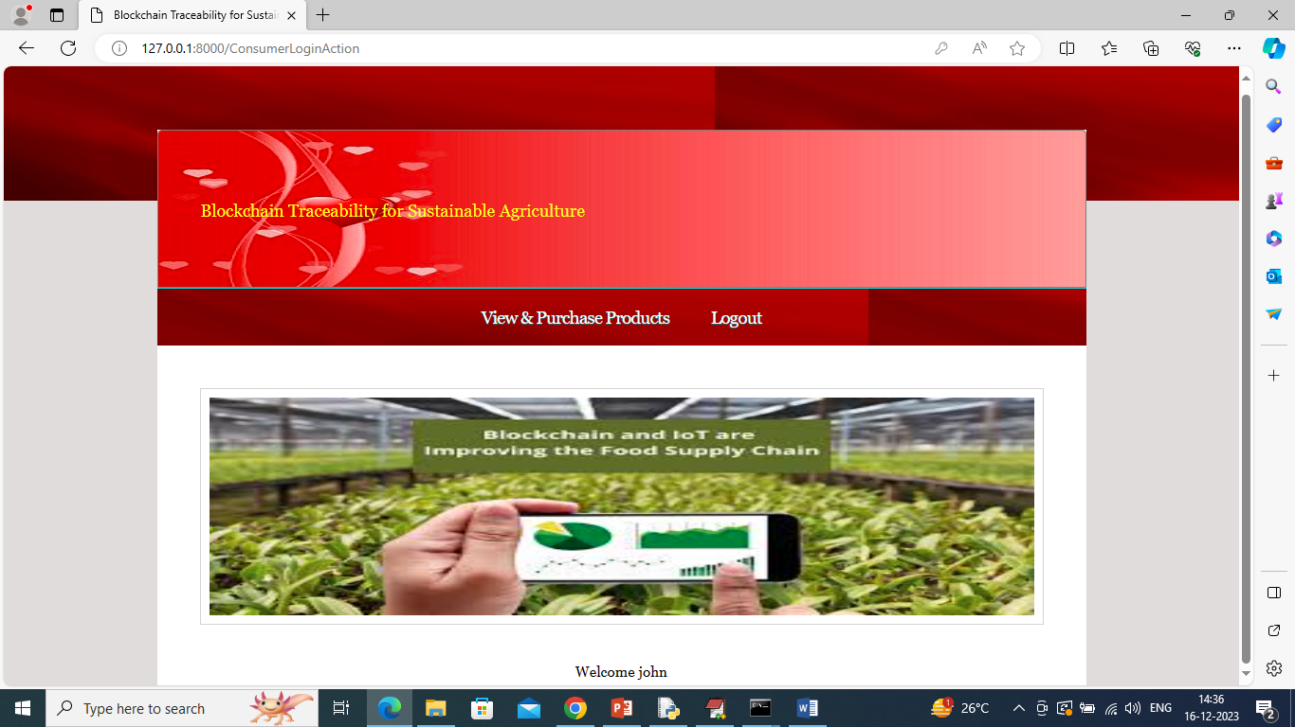

In above screen consumer can click on ‘View & Purchase Products’ link to get below page

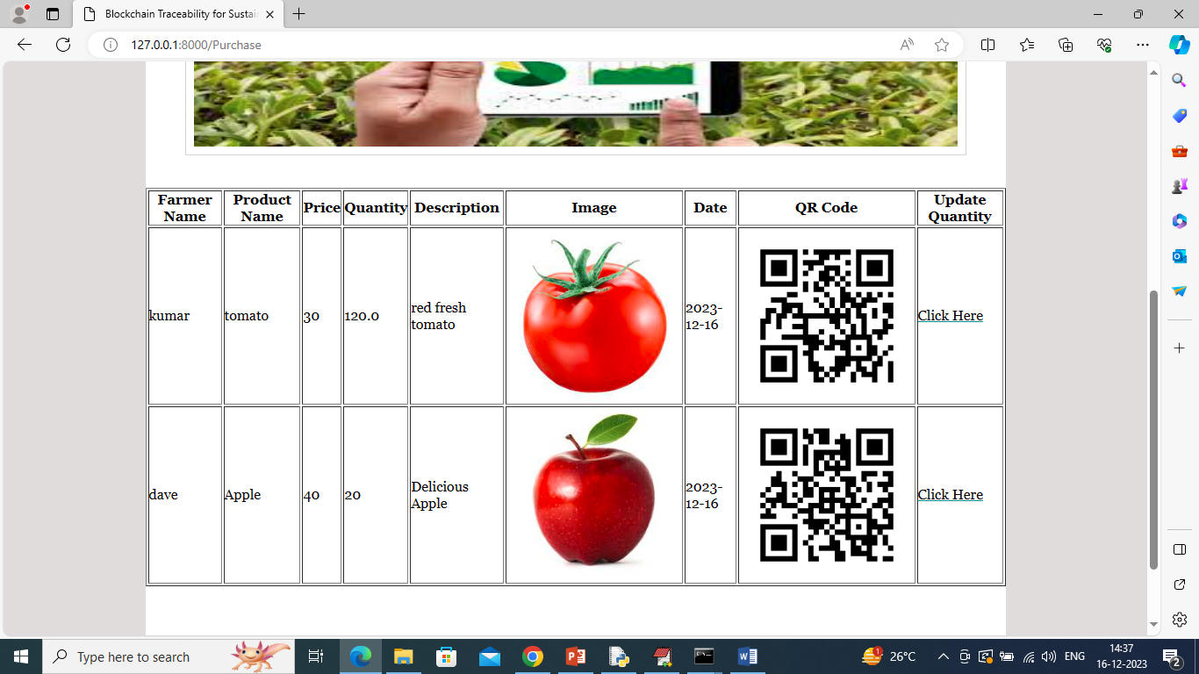

In above screen consumer can view products from all farmers and click on ‘Click Here’ link to purchase desired products and get below page

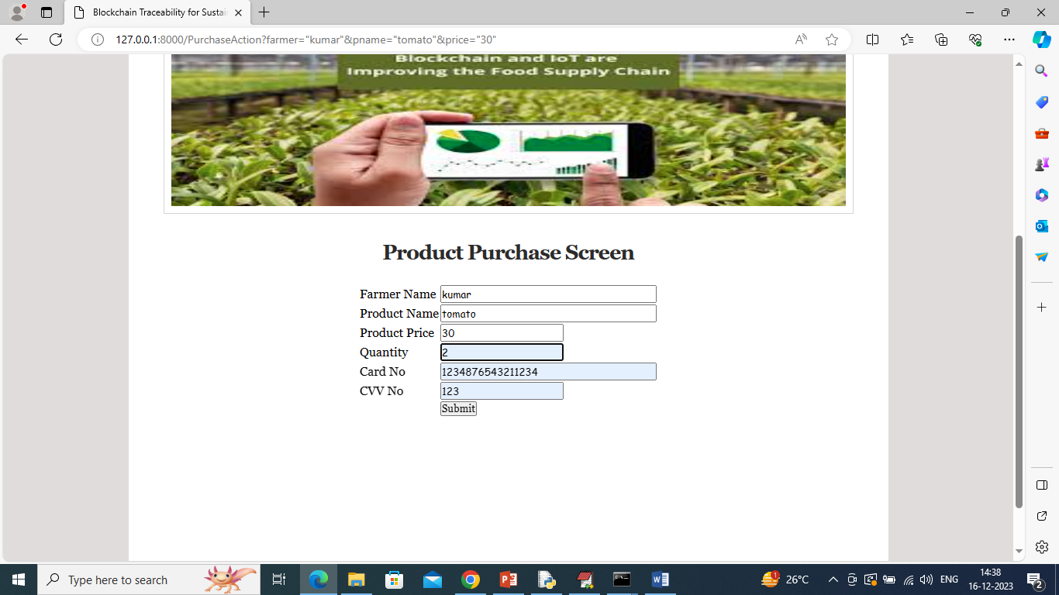

In above screen customer will enter quantity and card details to complete purchase and then press button to get below page

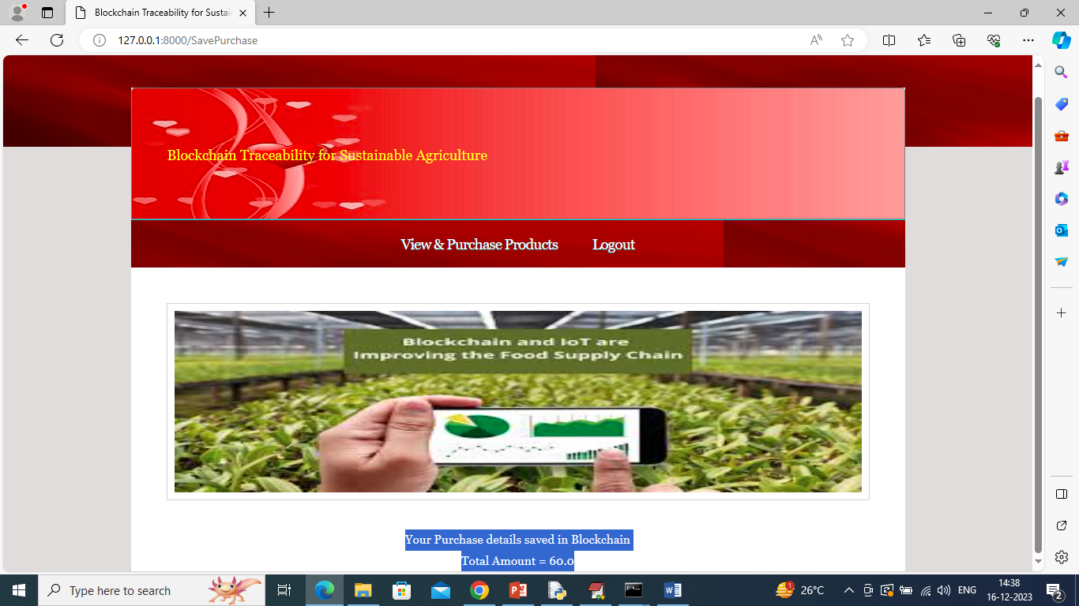

In above screen purchase details saved in Blockchain and total amount is 60 and now logout and login as farmer to view sales

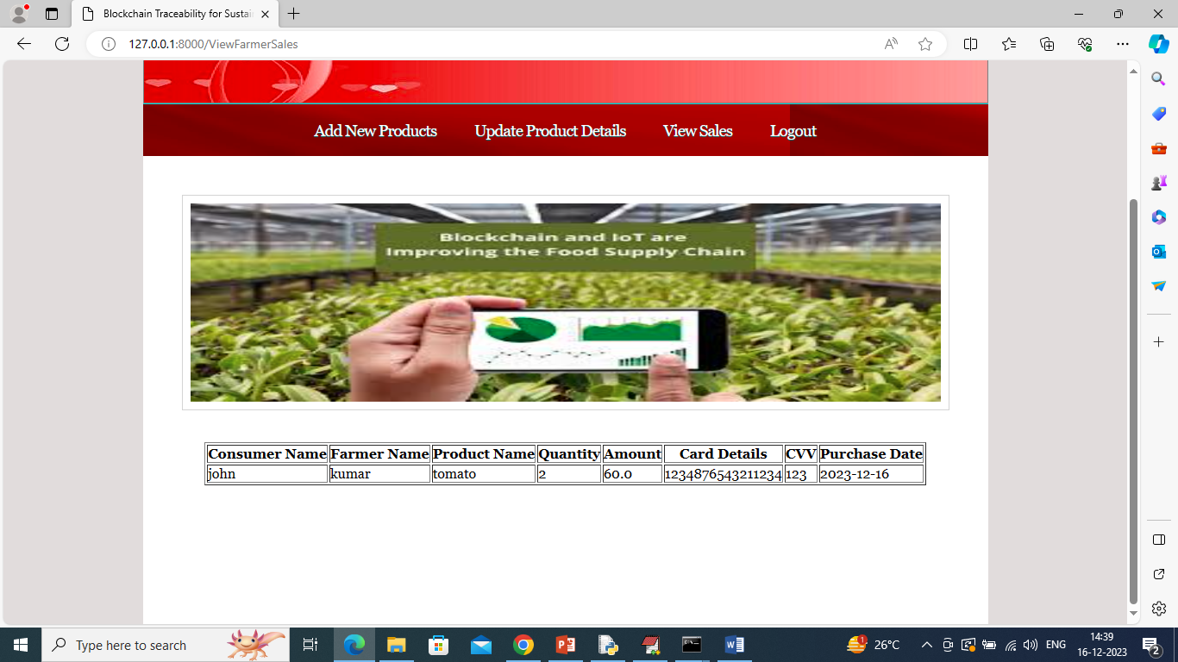

In above screen farmer can view which consumer purchase which product along with amount and quantity details.

So by following above screens user can manage and saved all details in Blockchain.